

**THE NATURE SIDE**

**GROUP MEMBER’S**

MUHAMMAD HAMZA

MUHAMMAD UZAIR

MUHAMMAD RAYAN

MUHAMMAD KHUBAIB

***Page No: 01***

***Page No: 0 1***

# *Certificate of Completion*

This is to certify that **Muhammad Hamza, Muhammad Uzair, Muhammad Rayan** and **Muhammad Khubaib** have successfully completed their ACCP Semester I E-Project.

Submitted to: **Aptech Computer Education**

On

**January 28th, 2023**

***Page No: 0 2***

# 

# *Acknowledgement*

First of all we would like to thank Almighty Allah for giving us strength and ability to complete this project.

And then, we would like to express my special thanks of gratitude to our teacher **Sir Ahmad Ali**  guided us on the project *Kitchen Appliances*, which also helped us in doing a lot of new learning and we came to know about so many new things we are really thankful to him.

We are highly thankful to **Sir Ahmad Ali** for his guidance and constant supervision as well as for providing necessary information regarding the project & also for his support in completing the project.

Lastly, we would also like to thank our parents and friends who helped us a lot in finalizing this project within the limited time frame. We also express our sincere gratitude to E-Project team from Aptech Head Office, for their valuable guidance and support for the completion of this project. We earnestly hope that this project will provide all the necessary information required by the user to fulfill his/her inspiration. However, suggestion and Feedbacks for improvements will be thankfully welcomed & acknowledged*.*

***Page No: 0 3***

***Page No: 0 3***

# *Project Synopsis*

The Nature Side is website that provides an online guardian for natural parks in Pakistan. You easily find knowledge about their history, tourism, and wildlife of parks. The main purpose to make this website is define how adorable and beautiful Pakistan is.

***Page No: 0 4***

***Page No: 04***

# *Problems Statement:*

Web portal for National parks is a website which provides the people who are interested in visiting national parks and interested in wild animals can view this website to where they can get to know where the national park is situated and what all animals residing in that national park. The existing system uses manual operations for Maintaining information of the national park and animals residing of that particular park in paper and files which may be damaged due to externals causes like fire, water etc. as a result it may lead to loss of information gathered permanently. And each national park may require a new record to store the information about that park which may also lead to so many records were finding it in set of national park records may be too difficult. Existing system which was performed using manual operations overcomes by the proposed system called “National Parks” where viewing national parks and wild life in that particular park from anywhere in the world. You are supposed to create a website for them with the below mentioned requirement specifications. The website is to be developed for the Windows Platform using HTML5, JavaScript and Geolocation. The site should work well in all leading browsers including Chrome, IE, Firefox etc.

***Page No: 0 5***

# ***Hardware and Software Requirements***

**Hardware**

* A minimum computer system that will help you access all the tools in the courses is a Pentium 166 or better
* 64 Megabytes of RAM or better

**Software**

* Notepad/HTML editor
* Dreamweaver
* IE 5.0/ Netscape 6.0

***Page No: 0 6***

# ***Architecture And Design of The System***

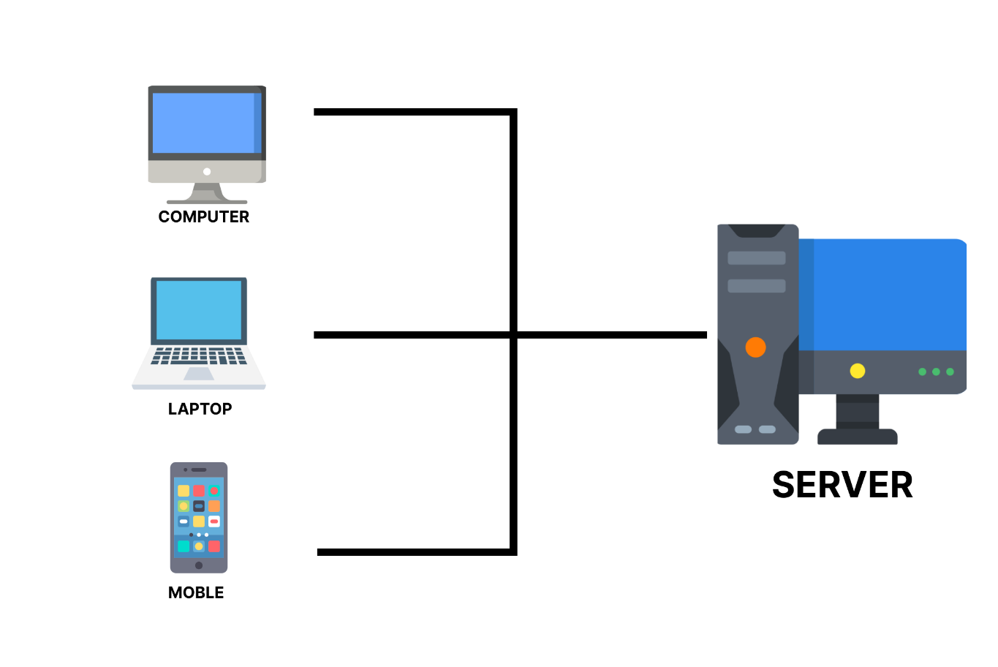

**Front End Technologies**

* Html 5
* CSS
* Bootstrap
* Json

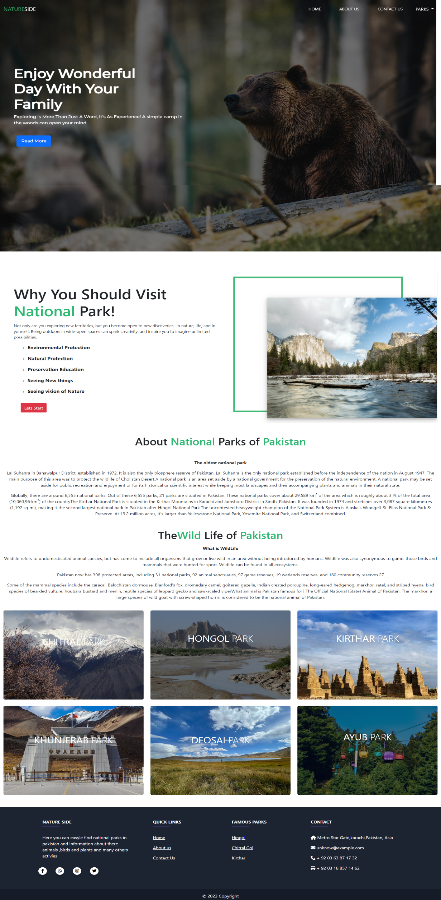

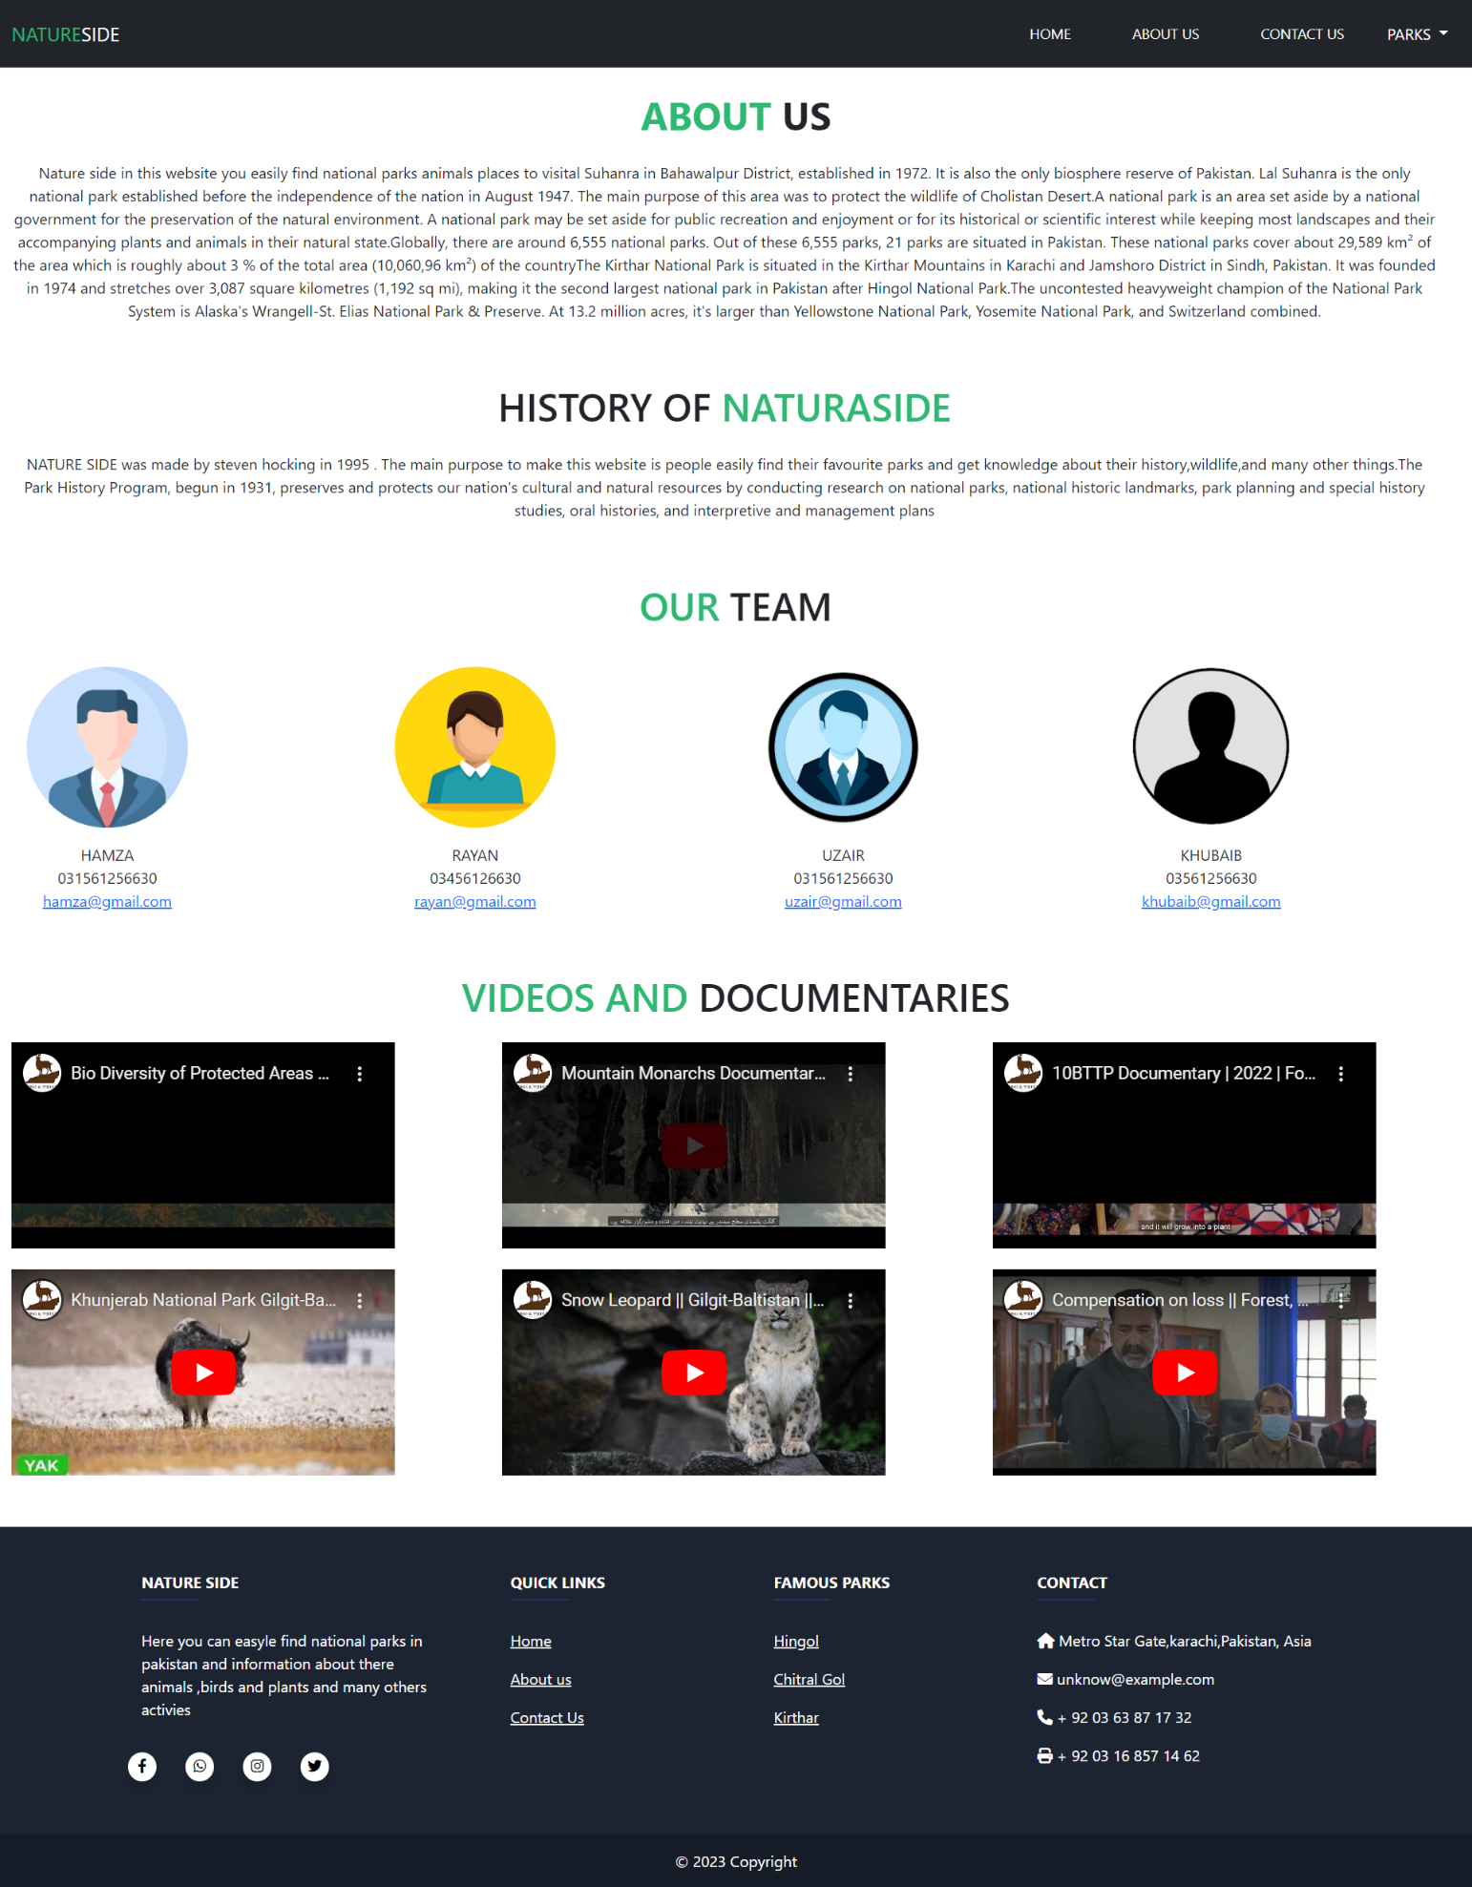

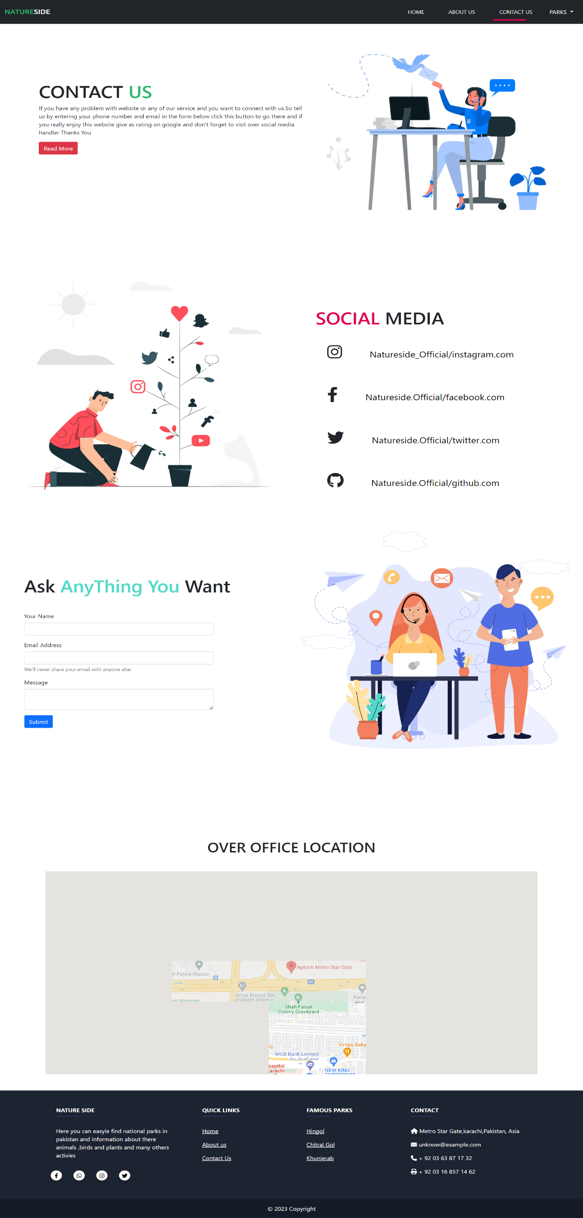

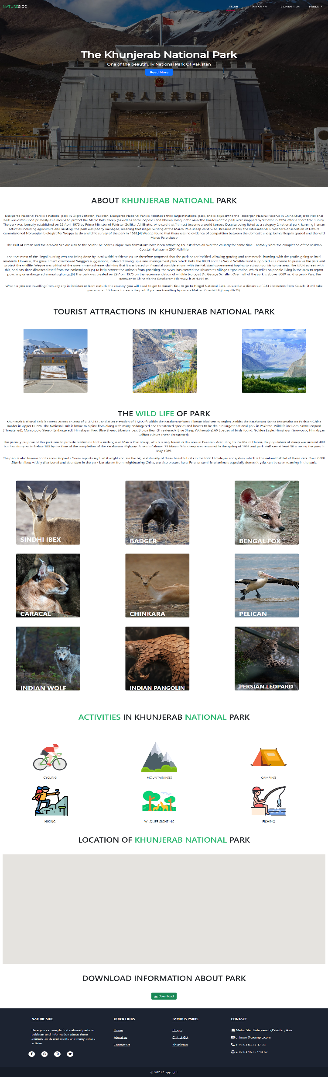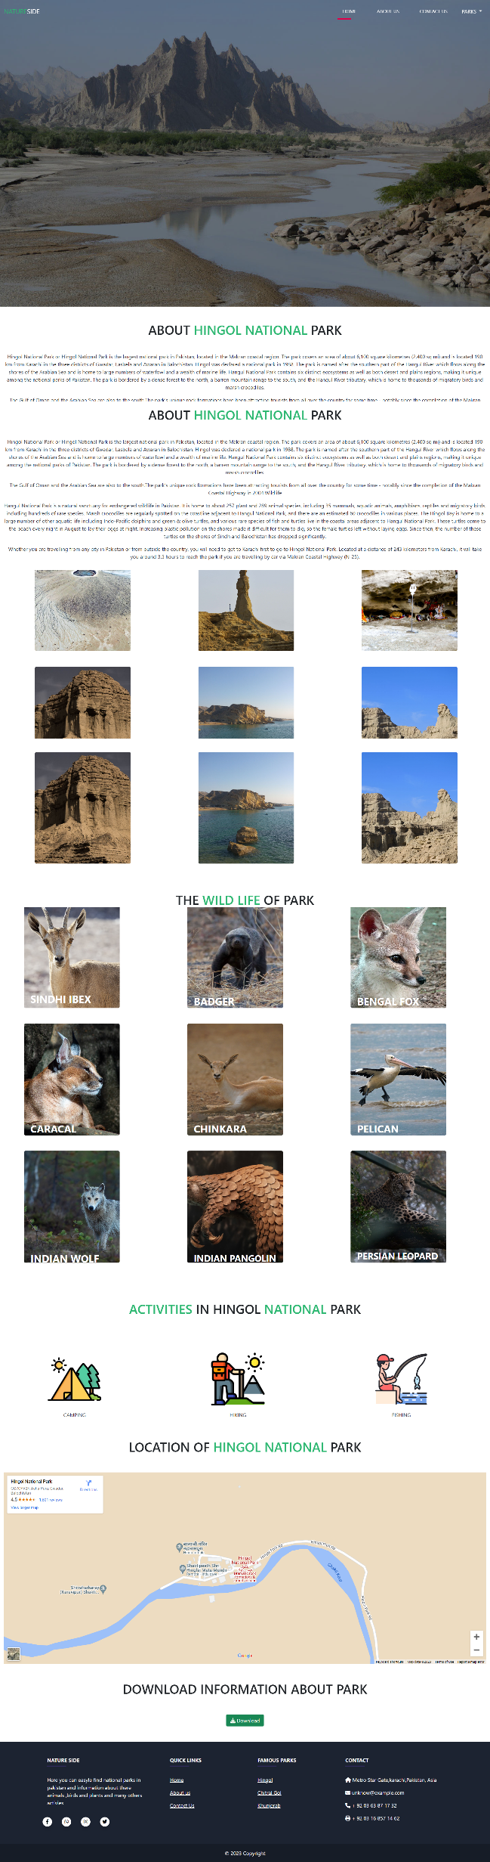

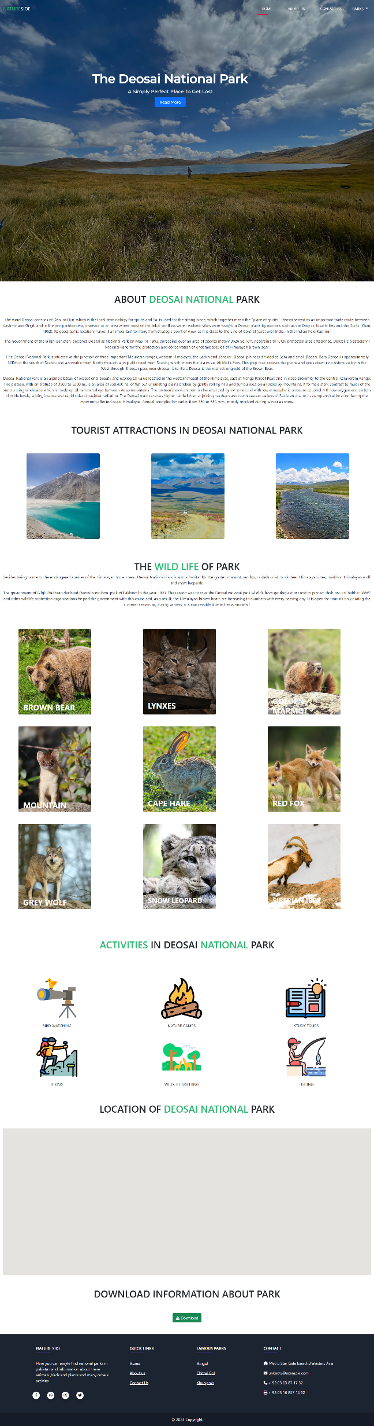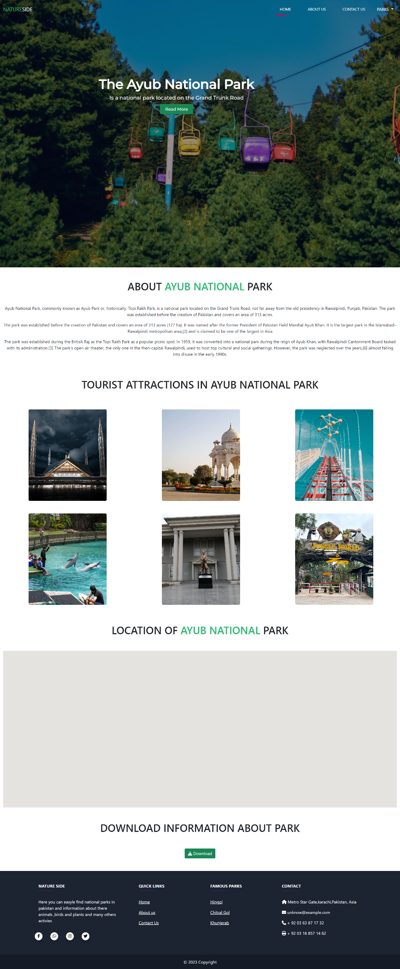

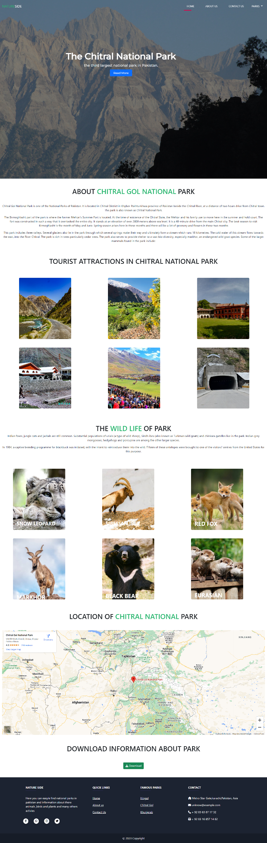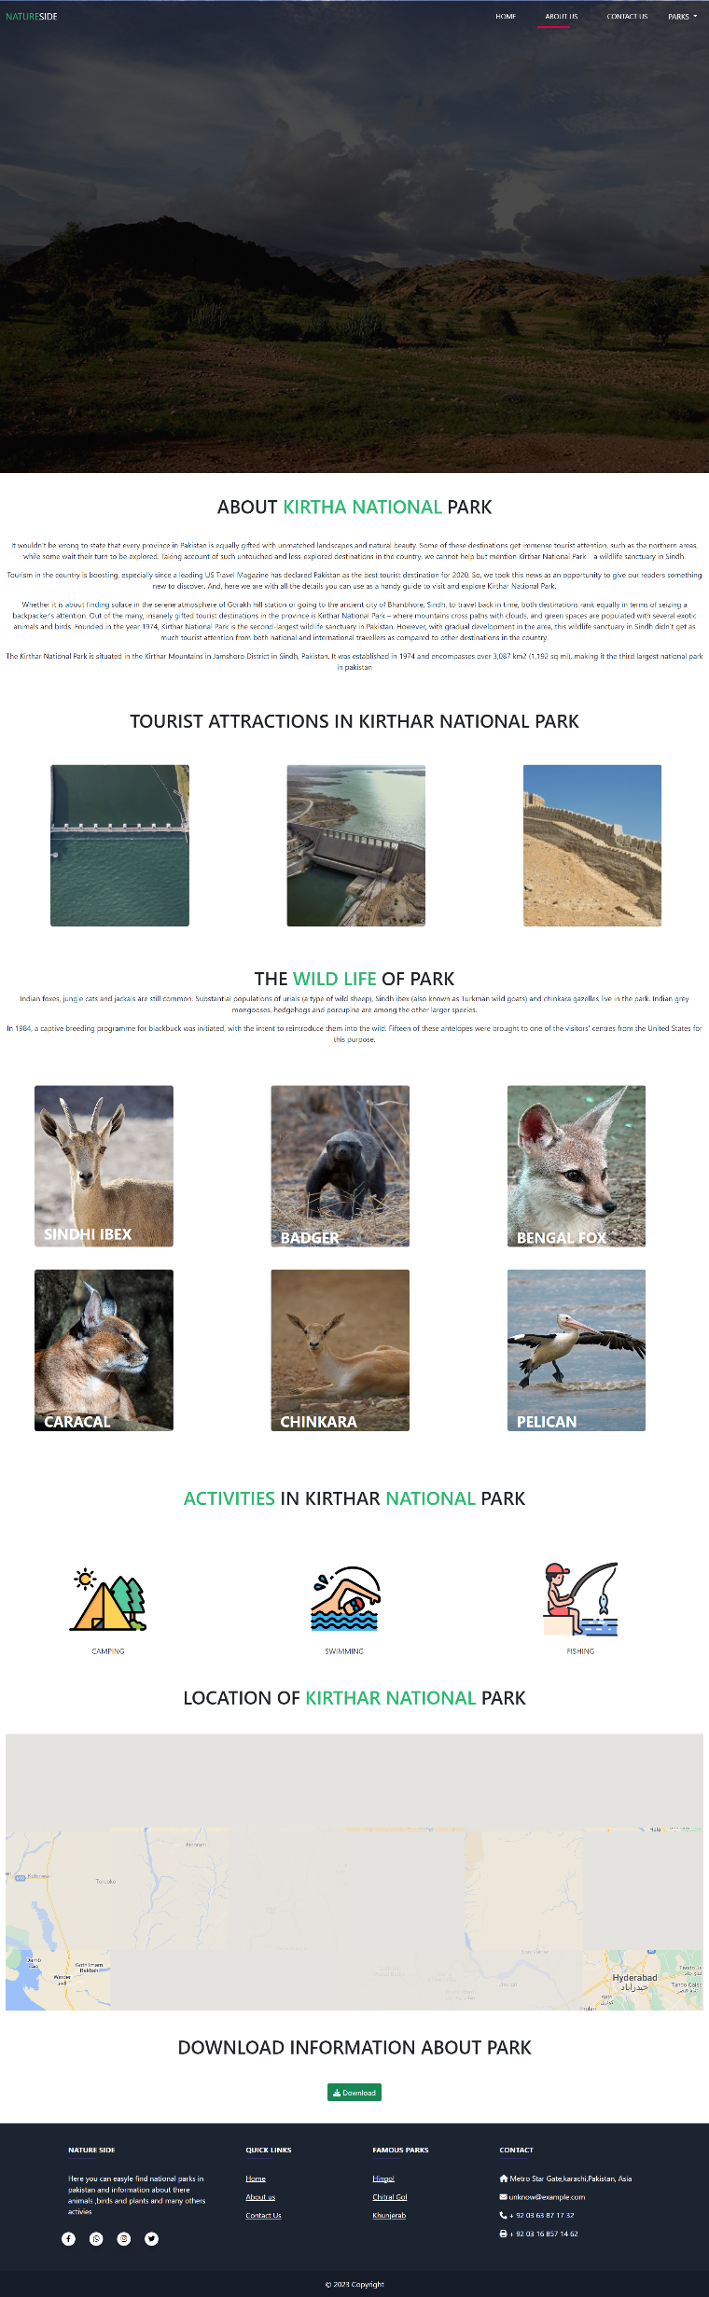

# 

***Page No: 13***

# ***Site Map***

***Page No: 14***

***Task Sheet***

|  |  |  |  |  |  |  |
| --- | --- | --- | --- | --- | --- | --- |
| **Project Ref. No:** | | **Project Title:** | **Data of Preparation of Activity Plan** | | | |
|  |
|  |
| Sr. No. | Task | Actual Start Data | Actual Days | Team Mate Name | Status |  |
|  |
| 1 | Analysis | Nature Side | 24-12-20222 | 2 | Khubaib | ok |  |
| 2 | Design |  | 25 | Hamza | ok |  |
| 3 | Responsive |  | 15 | Hamza | ok |  |
| 4 | Development |  | 25 | Hamza | ok |  |
| 5 | Data Collecting |  | 3 | Rayan | ok |  |
| 6 | Testing |  | 1 | Rayan, Uzair | ok |  |
| 7 | Documentation |  | 1 | Hamza | ok |  |
| 8 | Home Page |  | 5 | Hamza | ok |  |
| 9 | About Page |  | 1 | Khubaib, Hamza | ok |  |
| 10 | Contact Page |  | 1 | hamza, Uzair | ok |  |
| 11 | Hingol park Page |  | 6 | Hamza | ok |  |
| 12 | Kirthar park page |  | 3 | khubaib | ok |  |
| 13 | Chitral park page |  | 2 | Rayan | ok |  |
| 14 | Deosai park page |  | 1 | Uzair | ok |  |
| 15 | Ayub Park page |  | 1 | Khubaib | ok |  |
| 16 | khunjerab park page |  | 2 | Uzair | ok |  |